**Detailed Report on Battery Data Extraction from DALY BMS using UART and CAN Protocols**

* **Revision Number:**  
  Rev. 1.0
* **Date of Creation or Update:**  
  18/12/2024
* **Prepared By:**  
  Maria Tabasum Shoaib (Firmware Engineer)
* **Edited and Updated By:**
* **Reviewed By:**
* **Approved By:**

**Contents:**

* 1. **Overview**
  2. **Data Extraction Methods**
  3. **Data Points Explained**
  4. **Benefits of CAN Protocol in Automotive Applications**
  5. **Rationale for Choosing 72V 60A BMS**
  6. **Conclusion**

**1. Overview**

The DALY Battery Management System (BMS) is a key component in monitoring and managing the health and performance of electric bike batteries. This document outlines the process of data extraction using both UART and CAN ports, the types of data extracted, and the benefits of utilizing the CAN protocol, especially in automotive applications.

**2. Data Extraction Methods**

The DALY BMS (shown in Fig. 2) supports two primary communication protocols for data extraction:

**2.1 UART Communication**

* **Description**: UART (Universal Asynchronous Receiver-Transmitter) is a serial communication protocol that transmits data asynchronously, often over two wires (TX, RX).
* **Setup**:
  + Connect the TX and RX pins of the DALY BMS UART port to the ESP8266.
  + Proper baud rate configuration is essential for stable communication.
* **Working:**  
   The Universal Asynchronous Receiver Transmitter (UART) block diagram has two main components. They are the receiver and transmitter. These two components are coupled with a baud rate generator. This is used mainly for speed generation when the receiver and transmitter section has to receive or transmit data.  
    
  The receiver section consists of shift register, control logic and a receive hold register. Likewise, transmitter section also has a shift register, control logic and a transmit hold register. The transmitter hold register contains the data to be transmitted. The shift registers in the two components move the data bits left or right till the data transmission or receive operation is completed.

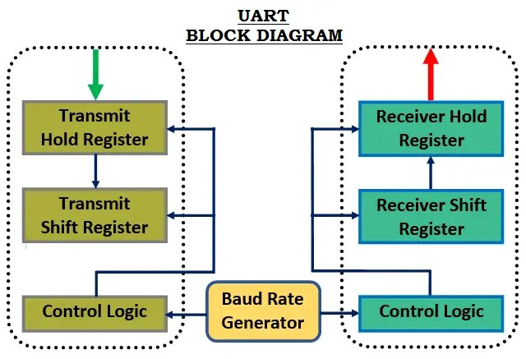

**Figure 2:** Block diagram of UART

* **Data Extracted**:
  + Total Voltage
  + Current
  + State of Charge (SoC)
  + Battery Temperature
  + Charge MOS State
  + Remaining Capacity
  + Charger Status
  + Individual Cell Voltages
* **Limitations**:
  + Limited speed and data integrity.
  + Limited support for automotive-grade environments.

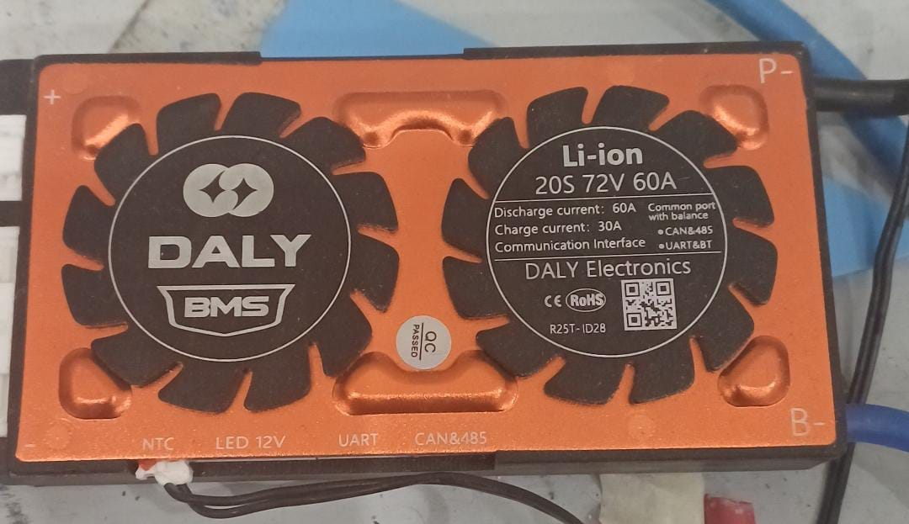

**Figure 2:** DALY BMS

**2.2 CAN Communication**

* **Description**: CAN (Controller Area Network) is a robust serial communication protocol designed for high-speed, reliable communication in automotive and industrial applications.
* **Setup**:
  + Use the CAN port of the DALY BMS to connect with a CAN transceiver.
  + Configure CAN bus parameters like baud rate (e.g., 250 kbps).
  + Ensure proper CAN bus termination (120Ω resistors).
* **Working:**  
   CAN allows multiple nodes, or devices, to connect to the bus on a single line, where each node can operate as a transmitter or receiver at any time. CAN nodes do not have strict master/slave roles and can operate without the need for a centralized host; instead, data messages are broadcasted across the bus and each node determines if the message is relevant based on the frame “identifier”, which describes the message’s contents.

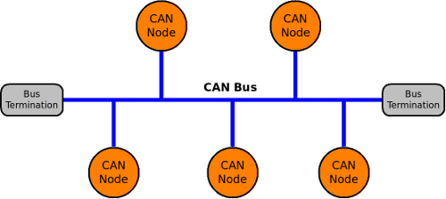

**Figure 3:** Diagram of the CAN Bus

* **Data Extracted**: The same dataset is extracted as in UART but with better efficiency:
  + Total Voltage
  + Current
  + State of Charge (SoC)
  + Battery Temperature
  + Charge MOS State
  + Remaining Capacity
  + Charger Status
  + Individual Cell Voltages

**3. Data Points Explained**

**3.1 Total Voltage**

* **Definition**: Sum of the voltages across all individual cells.
* **Significance**: Helps monitor the overall state of the battery pack.

**3.2 Current**

* **Definition**: Current flow into or out of the battery (measured in Amps).
* **Significance**: Indicates charging or discharging conditions of the battery.

**3.3 State of Charge (SoC)**

* **Definition**: Remaining energy in the battery, expressed as a percentage.
* **Significance**: Critical for understanding battery usage and range estimation.

**3.4 Battery Temperature**

* **Definition**: Temperature of the battery cells or pack.
* **Significance**: Overheating can cause thermal runaway, reducing battery life and safety.

**3.5 Charge MOS State**

* **Definition**: Status of the charge Metal-Oxide-Semiconductor (MOS) switch (ON/OFF).
* **Significance**: Indicates if the battery is actively being charged.

**3.6 Remaining Capacity**

* **Definition**: Energy left in the battery, usually measured in Ah (Ampere-hours).
* **Significance**: Helps determine how much energy is left before recharging is required.

**3.7 Charger Status**

* **Definition**: Indicates whether the charger is connected and actively charging.
* **Significance**: Useful for debugging and monitoring charging operations.

**3.8 Individual Cell Voltages**

* **Definition**: Voltage readings of each cell in the battery pack.
* **Significance**: Ensures cell balancing and identifies weak or faulty cells.

**4. Benefits of CAN Protocol in Automotive Applications**

The CAN protocol offers several advantages over UART, particularly in automotive and electric bike applications:

**4.1 Reliability and Robustness**

* Designed for harsh environments with high noise levels.
* Provides error detection and correction mechanisms (CRC, ACK).

**4.2 High-Speed Data Transfer**

* CAN supports higher baud rates (up to 1 Mbps), enabling faster data communication compared to UART.
* Allows real-time monitoring of battery parameters.

**4.3 Multi-Master Communication**

* Supports multiple devices (nodes) on a single bus.
* Essential for complex automotive systems with multiple controllers (e.g., motor controller, BMS, charger, dashboard).

**4.4 Reduced Wiring**

* CAN operates on a two-wire system (CAN_H, CAN_L), reducing the weight and complexity of wiring harnesses.
* Critical for lightweight electric bikes and vehicles.

**4.5 Fault Tolerance**

* CAN continues to operate even if one node fails, ensuring system reliability.
* Features automatic retransmission of failed messages.

**4.6 Scalability**

* Easy to add more devices or sensors to the CAN bus without major changes to the communication system.
* Useful for expanding electric vehicle functionalities.

**4.7 Standardization**

* CAN is widely adopted in the automotive industry (ISO 11898), ensuring interoperability among different devices and systems.
* Supports advanced protocols like CANopen and SAE J1939.

## ****5. Rationale for Choosing 72V 60A BMS****

### ****5.1 Voltage and Current Requirements****

The electric bike's battery system operates at **72V** with a current rating of **30A**. Although the battery current is 30A, a **72V 60A BMS** was selected to ensure the system could handle peak loads and provide additional safety margins.

* **Voltage Compatibility:**  
  A 72V BMS matches the battery pack’s nominal voltage, ensuring safe and efficient energy management.
* **Current Handling:**  
  The **60A BMS** allows for higher current capacity, ensuring the system can handle:
  + **Peak Power Demands:** Sudden spikes in current during acceleration or heavy loads.
  + **Future Scalability:** If the battery pack is upgraded to a higher current output, the same BMS can still be used.

**6. Conclusion**

The DALY BMS provides comprehensive battery monitoring capabilities via UART and CAN communication protocols. While UART is simple and effective for basic applications, the CAN protocol is superior for automotive and high-performance systems due to its speed, robustness, and ability to handle complex networks. Leveraging CAN in electric bikes ensures reliable and efficient monitoring of battery data, enhancing overall performance and safety.